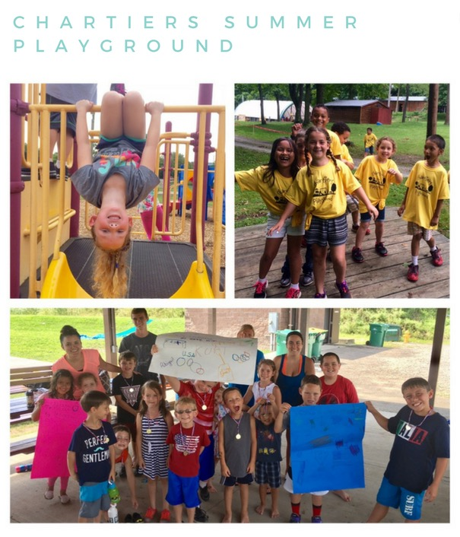

**COST: Fees for 4-5 Days/week**

**1 child- $145/2 children- $240/3 children -$330**

**Fees for 2 or 3 days**

**1 child- $95/2 children- $150/3 children -$195**

***Additional $10 fee on field trip days***

***Program runs 9am-4pm with optional early pickup/drop off 7am-6pm***

***Program is for children ages 5-11***

***All employees will have background checks and Act 33/34 clearances***

***NO DROP INS. PRE REGISTRATION IS REQUIRED***

***A MANDATORY PARENTS MEETING WILL BE HELD ON***

***THURSDAY, JUNE 1st @ 6:30 P.M.***

***———————————————————————————————————-***

***CHARTIERS TWP. SUMMER PLAYGROUND REGISTRATION FORM***

***PARENT NAME___________________________ PHONE___________________***

***ADDRESS____________________________________________________________***

***EMAIL_________________________________________***

***CHILD NAME___________________________________ SHIRT SIZE __________***

***CHILD NAME___________________________________ SHIRT SIZE __________***

***CHILD NAME ___________________________________SHIRT SIZE __________***

***Please select weeks child will be attending. Payment is due 1 week in advance.***

|  |  |  |  |  |  |  |  |  |  |
| --- | --- | --- | --- | --- | --- | --- | --- | --- | --- |
| June 12-18 | June 19-23 | June 26-30 | July 3-7 | July 10-14 | July 17-21 | July 24-28 | Jul 31-Aug 4 | Aug 7-11 | Aug 14-18 |
|  |  |  |  |  |  |  |  |  |  |

***Mail registration form with a $25 nonrefundable deposit to Chartiers Summer Playground,***

***2013 Community Center Dr., Houston, PA 15324***