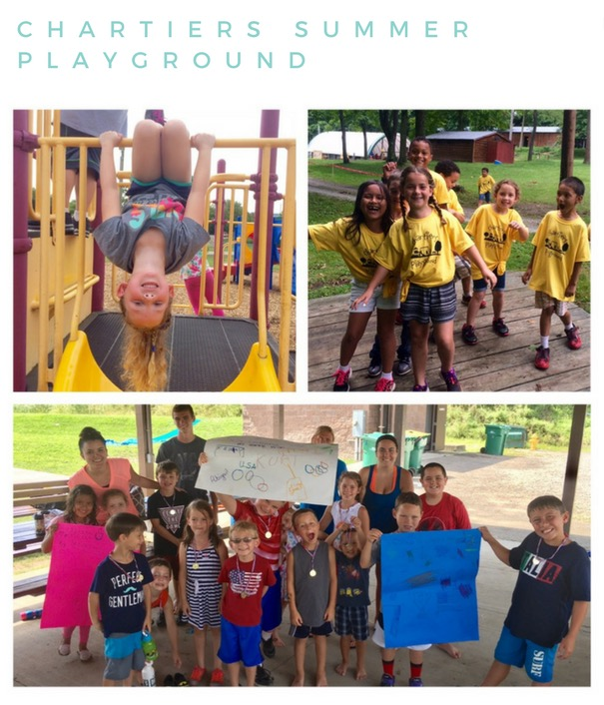

**COST: Fees for 4-5 Days/week**

**1 child- $145/2 children- $240/3 children -$330**

**Fees for 2 or 3 days**

**1 child- $95/2 children- $150/3 children -$195**

***Additional $10 fee on field trip days***

***Program runs 9am-4pm with optional early pickup/drop off 7am-6pm***

***Program is for children ages 5-11***

***NO DROP INS. PRE REGISTRATION IS REQUIRED***

***A MANDATORY PARENTS MEETING WILL BE HELD ON***

***WEDNESDAY, MAY 27TH @ 6:30 P.M.***

***———————————————————————————————————-***

***CHARTIERS TWP. SUMMER PLAYGROUND REGISTRATION FORM***

***PARENT NAME___________________________ PHONE___________________***

***ADDRESS____________________________________________________________***

***EMAIL_________________________________________***

***CHILD NAME___________________________________ SHIRT SIZE __________***

***CHILD NAME___________________________________ SHIRT SIZE __________***

***CHILD NAME ___________________________________SHIRT SIZE __________***

***Please select weeks child will be attending. Payment is due 1 week in advance.***

|  |  |  |  |  |  |  |  |  |  |
| --- | --- | --- | --- | --- | --- | --- | --- | --- | --- |
| June 8-12 | June 15-19 | June 22-26 | June 29-July 3 | July 6-10 | July 13-17 | July 20-24 | July 27-31 | August 3-7 | August 10-14 |
|  |  |  |  |  |  |  |  |  |  |

***Mail registration form with a $25 nonrefundable deposit to Chartiers Summer Playground,***

***2013 Community Center Dr., Houston, PA 15324***